Project title: Library Arrangement system

Section: G

Group: 07

Submitted by:

|  |  |
| --- | --- |
| NAME | ID |
| RAHUL DAS | 19-40241-1 |
| PRITOM MAJUMDAR | 19-40146-1 |
| SOUMIK DAS | 19-40143-1 |
| PROSENJIT BISWAS | 19-39637-1 |
| MIRZA MD. TAWHID | 20-42643-1 |

Specification:

A Library Arrangement system is a software that uses to maintain the record of the library. It contains work like the number of available books in the library, the number of books are issued or returning or renewing a book or late fine charge record, etc. Library Arrangement Systems is software that helps to maintain a database that is useful to enter new books & record books borrowed by the members, with the respective submission dates. Moreover, it also reduces the manual record compulsion of the librarian.

Overall use case diagram:

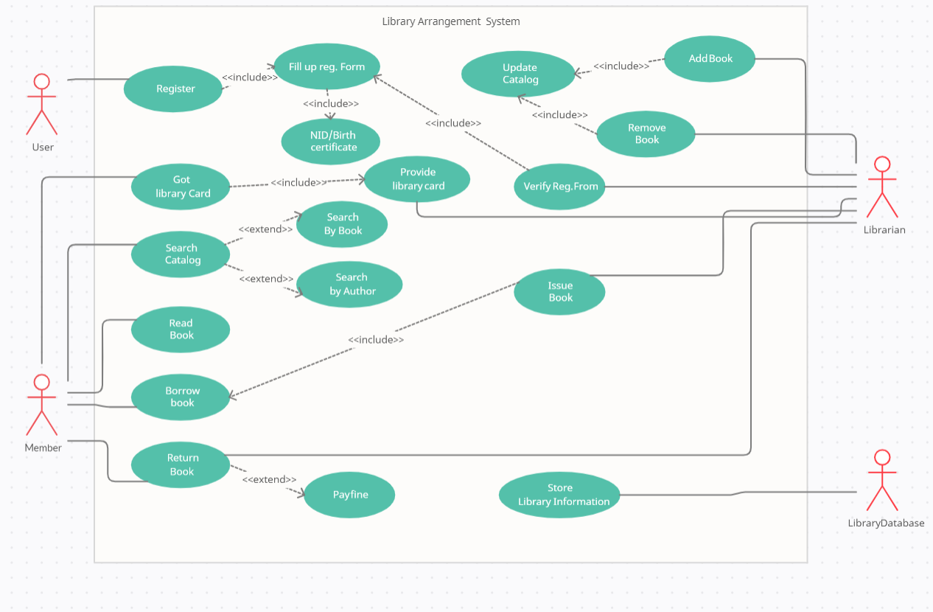

In this use case diagram there are 4 Actors and some use cases. First of all user connect with register. So, we need NID/Birth certificate first and then we fill up registration form for register so we do include in there. There second actor is member which is connected got library card, search catalog, read book, borrow book, return book. For got library card we need provide library card first so we do include in there. Again for search catalog search by book and author is not mandatory so it is extends. Borrow book include relation with issue book and return book extend relation with pay fine. In there our 3rd actor is Librarian and it is connected with add book, remove book, verify reg form, provide library card , issue book and return book. In there add book and remove book are include relation with update catalog. For the verify reg form we need to fill up reg form first. So there is include relation. Finally our last actor is Library database which is connected to use case library store information.

Activity diagram:

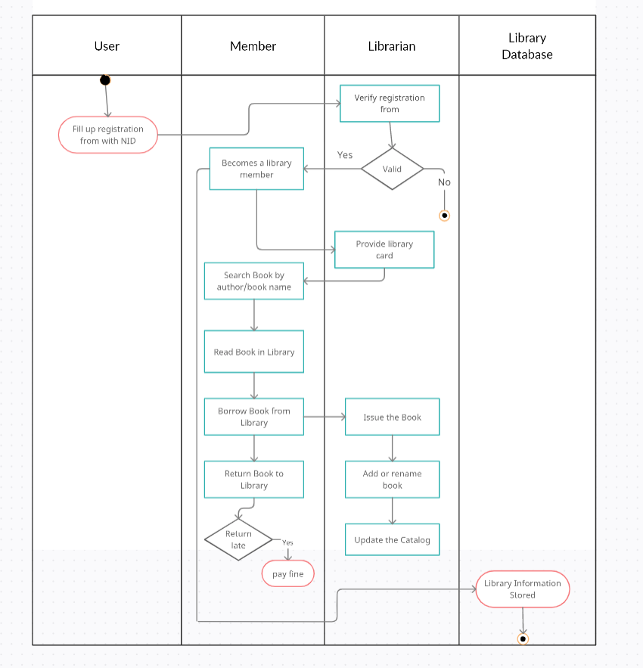

Here we start the diagram with field circle.1st activity in our diagram user can register in the system with NID. After registering librarian will verify this registration from that user did. Librarian will check that whether the information that given by user it is valid or not. If it is not valid than librarian will reject the form and if it is valid user will be library member. Then the member can use his Library card that given by Librarian. With this library card member can search book from the library by book or author name. Besides member can read book in the library. Member can borrow book from the library for a limited time. After finishing the time member need to return the book. If member late to return the book then he/she need to pay fine for being late. After being member, all the information of the member will store in the library database. On the other hand, member can issue the book to the Librarian. Librarian will add or rename the book and will update the catalog. That’s how the activity diagram will work.

Class diagram:

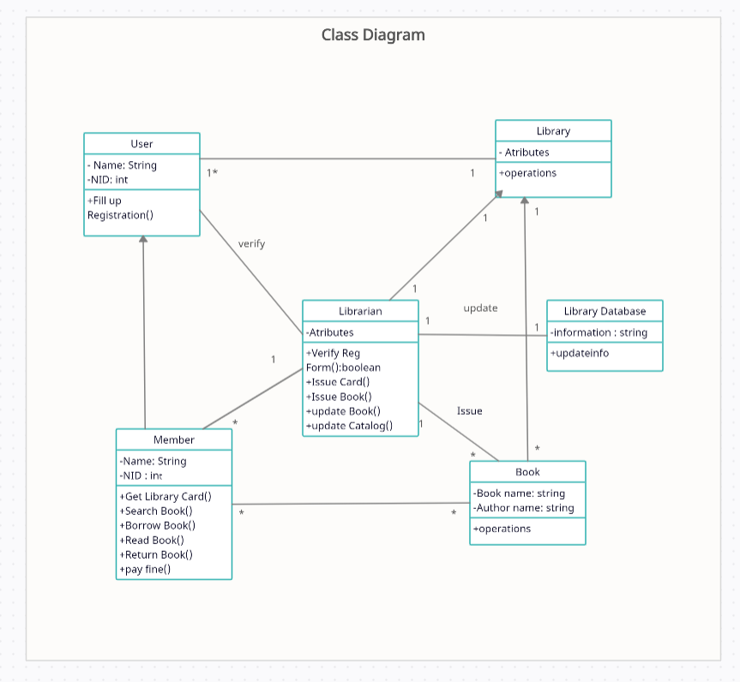

This diagram is about class diagram. In this diagram, firstly user need to fill up the registration form by their user name and nid. Librarian verify the registration form. If the form is valid then user becomes the member of the library.Then librarian issue library card to the member of the library. Many user can be verified by the librarian. After getting membership an user can read book in the library. He can search books according his needs from the book catalog. He can find his necessary books by books name or author name. Librarian can update books catalog according to the readers need. He can add books in the library and he can also remove books that has less demand. Member can borrow book from the library. If the book is available in the store then librarian gives the book to the member and keeps records in the database. Member needs to return the borrowed books in time. If he fails to return the book in time, he needs to pay fine for late returning.

Sequence diagram:

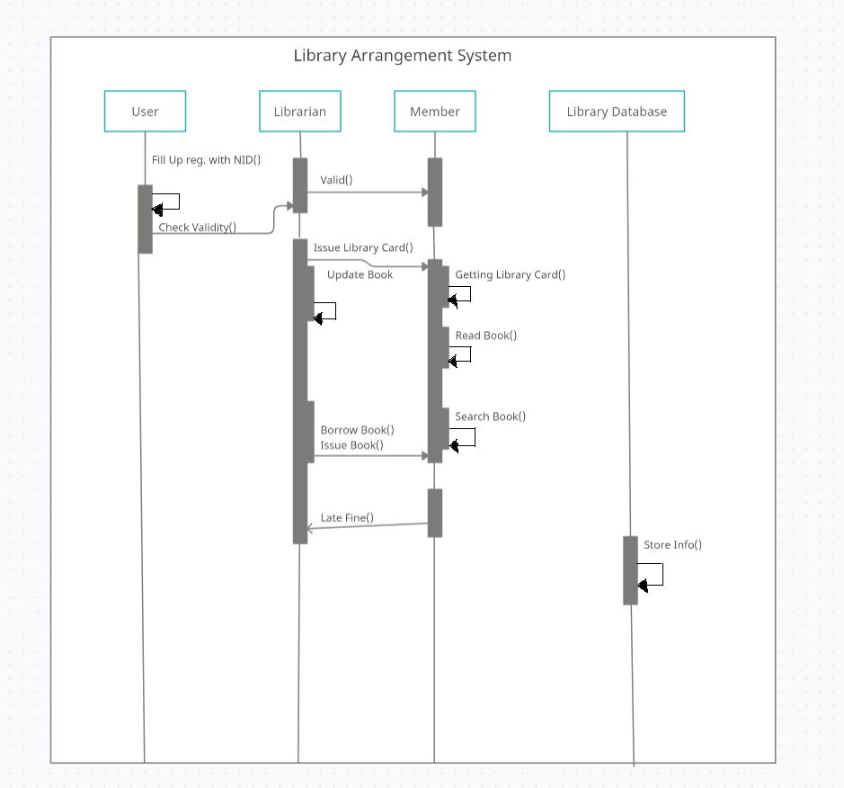

This diagram about sequence diagram. In this diagram we properly show the whole scenario of library arrangement system .There four property such as user, librarian , member and library database. For user needs to fill up registration from than librarian are verify the whole information and made him member. Than the member are valid to use all facility in library. Librarian issue the library card and member get this .In use the library card member read the book ,search book and also borrow the book from library and the librarian also issue the book from library .if any member don’t return the book in time than member need to pay fine from librarian .Lastly all of the information are stored in the library database.

Conclusion:

The project Library Management System is for computerizing the working in a library. This software allows storing the details of all the data related to library. The software takes care of all the requirements of an library and is capable to provide easy and effective storage of information related to books & users. The implementation of the system will reduce data entry time and provide readily calculated reports.